1. Just code from the previous lecture.
2. 
3. 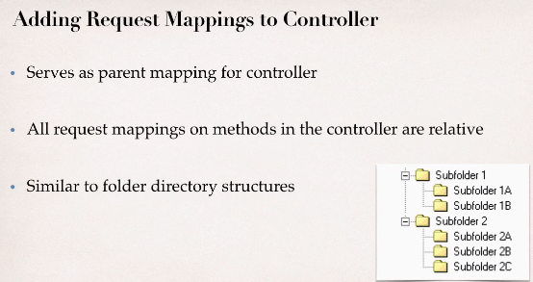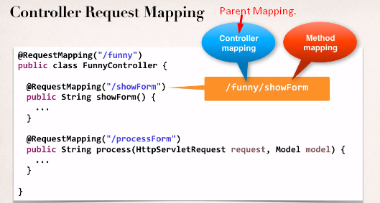
4. Why do we defining mapping at controller level?
   1. To group your request mappings together.
   2. A great technique for resolving any problems/conflicts that you may have with other request mappings.